|  |  |  |  |
| --- | --- | --- | --- |
|  | |  | |
| Internal Auditing and Compliance Management Report in Human Resources | | |  |
|  |  | | |
|  | | **2024/12/31****HR Management** | |
|  | | **Data Dynamos Team****DEPI** | |

|  |  |  |  |
| --- | --- | --- | --- |
|  |  |  |  |
|  | **1. Overview of Internal Auditing and Compliance Management in Human Resources:**  The Audit and Compliance Department in Human Resources ensures adherence to labor regulations, ethical policies, and internal controls. It plays a vital role in maintaining compliance with employment laws, fair workplace practices, and data protection policies.  **2. General Compliance Performance Analysis:**   * **Regulatory Adherence Rate:** The department ensures compliance with labor laws and workplace regulations, achieving an adherence big rate. * **Internal Auditing Findings:** Recent audits identified key risk areas related to employee policies, payroll compliance, and workplace ethics. * **Employee Certification Levels:** A large percentage of employees hold relevant compliance certifications, ensuring expertise in labor law enforcement.   **3. Risk Management and Internal Controls:**   * **Workplace Ethics Monitoring:** Policies implemented to detect and address unethical practices. * **Policy Enforcement:** Regular assessments ensure employees comply with policies, including fair hiring, equal pay, and workplace safety. * **Training Programs:** Employees undergo annual compliance training to stay updated on labor law changes and ethical guidelines.   **4. Strengths:**   * Strong adherence to labor law regulations. * Effective auditing and compliance frameworks. * Well-structured risk management policies in employee relations. * High employee participation in compliance training programs.   **5. Challenges:**   * Increasing complexity of employment regulations requiring continuous updates. * Need for advanced compliance monitoring tools to enhance efficiency. * Expanding employee training on workplace ethics and anti-discrimination policies.   **6. Recommendations:**   * **Enhance Compliance Monitoring:** Implement AI-driven tracking systems to detect policy violations. * **Expand Training Programs:** Increase awareness through specialized compliance and labor law workshops. * **Improve Internal Auditing:** Leverage data analytics to assess workplace compliance risks. * **Strengthen Reporting Mechanisms:** Develop automated dashboards for real-time compliance monitoring.   **7. Predictive Insights:**   * Strengthening compliance monitoring can reduce legal risks by 15%. * Increasing employee participation in compliance training can improve adherence rates by 20%. * Implementing AI-based tracking tools can enhance auditing efficiency by 30%.   **8. Conclusion:**  The Auditing and Compliance Department plays a crucial role in ensuring ethical workplace practices and regulatory adherence. By optimizing compliance monitoring, enhancing training programs, and leveraging advanced tracking tools, the department can further improve risk management and maintain workplace integrity. | |  |
|  |  |  |  |

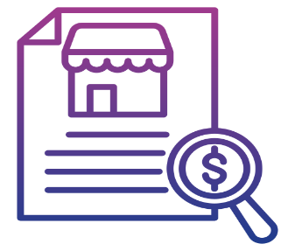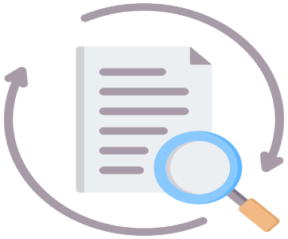

|  |  |  |
| --- | --- | --- |
|  |  |  |
| **Dear Internal Audit and Compliance Management Team,**   * We would like to extend our sincere appreciation and gratitude for your outstanding efforts and dedication over the past period. Your commitment, hard work, and valuable contributions have played a significant role in achieving our company's goals. * Your exceptional performance in driving Internal Audit and Compliance goals and meeting strategic targets has had a profound impact on our success. We truly appreciate your persistence and dedication to delivering outstanding results. The collaboration between departments is the foundation of our collective success, and we are proud to have such a dedicated team like yours within our organization.   **We look forward to continued success and even greater achievements together.**  **Thank you for your hard work, and we wish you continued success and excellence.**  **Best regards, Human Resources Department** [Data Dynamos Team] **DEPI** |
|  |

